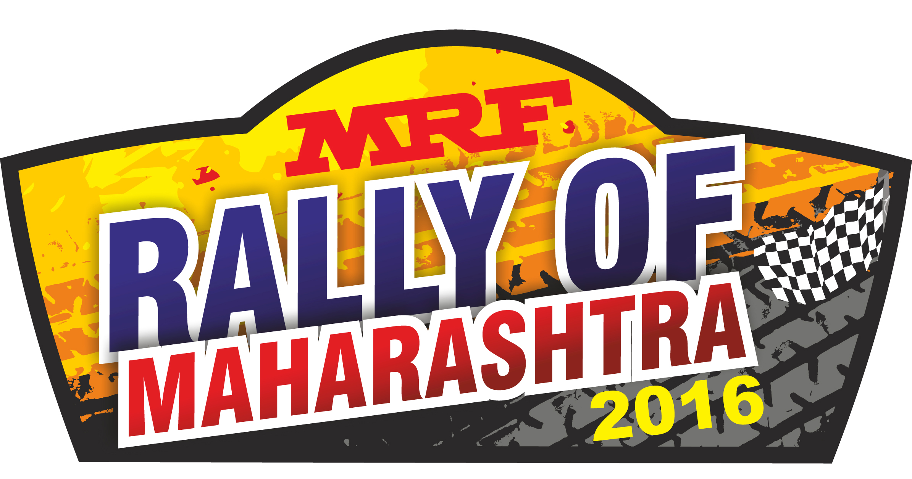

Round 2 of the

2016 MRF FMSCI Indian National Rally Championship

2016 MRF FMSCI Indian Rally Championship
MRF Rally of Maharashtra

27th August – 28th August 2016
Supplementary Regulations

Office Address

Western India Sports Association
Shop No. 2, Galaxy Apartment, Op. Tirupati Town,
Near Akashwani Centre, NASHIK- 422013.
Telephone: +91 253 2316067 Facsimile: + 91 253 2316397
E-Mail: wisa.ind@gmail.com Web site: www.wisa.org.in

Rally Headquarters
THE GATEWAY HOTEL,
P-17, MIDC Ambad, Mumbai-Agra Road Nashik 422010
Contact: 0253-660 3344 Fax: 91-253-660 3366
www.thegatewayhotels.com
INDEX
- Introduction 3
- Organization 3
- Programme 6
- Entries 8
- Insurance 12
- Advertising 13
- Tyres 13
- Fuel 13
- Reconnaissance 13
- Administrative Checks 14
- Scrutineering, Sealing and Marking 15
- Other Procedures 16
- Identification of officials 18
- Prizes 18
- Final Checks 19
16. Appendix 1 Itinerary 20
17. Appendix 2 Reconnaissance Schedule 21
18. Appendix 3 Competitor’s Relation Officer 22
19. Appendix 4 Compulsory Advertisement 23
20. Appendix 5 Service Park Procedures 25

1. INTRODUCTION
- The MRF Rally of Maharashtra is a round of MRF FMSCI Indian National Rally Championship (INRC) 2016 / MRF FMSCI INDIAN RALLY CHAMPIONSHIP (IRC) and will be run in compliance with the International Sporting Code of the FIA (and its appendices), the General Prescriptions of Federation of Motor Sports Clubs of India (FMSCI), the relevant Regulations concerning INRC/IRC championship or cup, these Supplementary Regulations and bulletins issued by FMSCI.
The Federation of Motor Sports Clubs of India (FMSCI) is ASN of FIA in India
Modifications, amendments and/or changes to these Supplementary Regulations will be announced only by numbered and dated bulletins (issued by Organisers or the Stewards).
- Road Surface All Special Stages are ASPHALT.
- Distance
Total Distance of the Rally 402.79KM
Total liaison Distance of the rally 331.39 KM
Total SS Distance of the rally 71.40 KM
2. ORGANISATION
2.1 FMSCI Titles for which Rally Counts
2016 FMSCI Indian Rally Champion Driver - Overall
2016 FMSCI Indian Rally Champion Co Driver -Overall
2016 FMSCI Indian Rally Champion Team – Overall

2016 FMSCI Indian National Rally Champion Driver - Overall
2016 FMSCI Indian National Rally Champion Co Driver - Overall
2016 FMSCI Indian National Rally Champion Team - Overall

2016 FMSCI Indian National Rally Champion Driver – 2000 cc
2016 FMSCI Indian National Rally Champion Co Driver – 2000 cc
2016 FMSCI Indian National Rally Champion Team – 2000 cc

2016 FMSCI Cup Winner Driver
2016 FMSCI Cup Winner Co Driver
2016 FMSCI Cup Winner Team

2.2 Permit No.
Permit Number TBA/2016 IRC
TBA /2016 INRC
TBA /2016 IRC 2000 cc
TBA /2016 FMSCI Cup
2.3 Organiser’s Name Western India Sports Association. (WISA)
Address & Contact Details
Permanent Secretariat Western India Sports Association
Shop No. 2, Galaxy Apartment, Op. Tirupati Town,
Near Akashwani Center, NASHIK - 422013,
Tel: + 91 253 2316067 Fax: + 91 253 2316397
E-Mail: wisa.ind@gmail.com
Web site: www.wisa.org.in
  - Organization Committee
Management Committee of WISA
PANDIT Ashwin PANDIT Swati YANDE Shreyas
DEOSTHALI Girish PATANI Nilesh AHIRE Ajay
SHUKLA Dinesh AGHARKAR Suhas WADWALKAR Rajeev

Organizing Committee of Rally
BURKULE Sameer YANDE Shreyas PANDIT Swati
SAKRIKAR Pranav BHAMREY Nitin MACHHE Shrirang
KURTADIKAR Anirudha KHARKAR Girish KULKARNI Sanjay

  - Stewards of the Meeting
Chairman of Panel Mr.Vicky Chandhok
FMSCI Steward Mr.Zavareh B Doctor
FMSCI Steward Mr.Shivu Shivappa
  - FMSCI Observer & Delegates
Observer Mr. Shivu Shivappa
Technical Delegate Mr. G. Sathish Kumar

  - Senior Officials
Clerk of the Course BURKULE Sameer
Deputy Clerk of Course WADWALKAR Rohan
Assistant Clerk of Course KURTADIKAR Aniruddha (Alpha)
GUJAR Anil (Beta)
SINHA Niranjan (Gama)
Secretary of the Meet SAKRIKAR Pranav

Competitor Relation Officer MACHHE Shrirang

Chief Scrutineer WAGHCHAURE Ravi
Chief Safety Officer BHAMARE Jeevan
Chief Medical Officer Dr. Maj. JOSHI D. C.
Media Relations Officer PANDIT Swati
Communication Chief DATAR Salil
Stage Commanders PATIL Sunil Alpha (SS 1/4)
DESHPANDE Chinmay Beta (SS 2/5)
UPASANI Aniket Gama (SS 3/6)
Dy. Stage Commander BHAMRE Nilesh Alpha (SS 1/4)
Stage Safety Officers KANNAV Ameya Alpha (SS 1/4)
KHARKAR Girish Beta (SS 2/5)
BHAMRE Shantanu Gama (SS 3/6)
Results Coordinator KULKARNI Aniruddha DARYANI Pavan
  - HQ location

Up to Thursday, August 25, 2016 at WISA’s Permanent Secretariat
Refer Art 2.3 of these regulations for Address & contact Details.
From Friday, August 26, 2016, 12.00 Hrs till Sunday, August ,28 2016, 22.00 Hrs at THE GATEWAY HOTEL , P-17 MIDC, Ambad, Mumbai Agra Road, Near Pathardi Phata, Nashik.

3. PROGRAMME
Opening date of entries up on publication of these regulations.
Sunday, August 14, 2016
20.00 Closing date of all entries.
Closing date of co-driver details.
Tuesday, August 16, 2016
17.00 Publication of Entry List.
Friday, August 26, 2016
11.00 Rally Office Opens – Rally HQ, The Gateway Hotel,
Official Notice Board – Rally HQ, The Gateway Hotel
13.30 – 15.30 Issuing of Road Book, Map & Rally Guide
Collection of Material and Documents
Collection of Competition Number Plates, Optional Advertising Stickers
15.30 Pre event Press Conference (By Invitation Only) – at The Gateway Hotel
17.00 Curtain Raiser Ceremony – City Centre Mall
18:00 Media Centre closes.
19.00 Rally Office closes.
Saturday, August 27, 2016
06.00 Rally Office opens
Administrative Checks starts.
Pre-event vehicle scrutiny starts (Refer Article 11.1 of S.R.)
06.00 – 11.40 Reconnaissance. SS (Last car expected to finish in Nashik at 12.30 Hrs. Refer Appendix II of S.R.)
11.00 Media Centre opens at The Gateway Hotel
13.00 Compulsory Driver’s Briefing Meeting at City Centre Mall
14:00 Ceremonial Start – City Centre Mall
14.45 Start of Shakedown– Sandip Foundation
19.00 1st Stewards Meeting, The Gateway Hotel.
19.30 Publication of Start List
20.30 Rally office closes.
Media Centre closes.
Sunday, August 28, 2016
05.30 Parc Ferme Closes for all classified cars, The Gateway Hotel.
Rally office Opens
06.30 Start of Rally- The Gateway Hotel.
08.00 Media Center Opens at The Gateway Hotel.
17.15 Podium Finish & Champaign shower ceremony at
The Gateway Hotel.
18.00 Post event Press Conference – The Gateway Hotel.
Final Scrutineering – City Center Mall
18:01 Parc Ferme closes for all classified cars – The Gateway Hotel.
20.30 Provisional Final Classification published – Rally HQ.
21.30 Media Centre closes.
22.00 Rally Office closes.

4. ENTRIES
4.1 Opening and Closing Dates
Opening date for entries with the publication of these Regulations
Final Closing date for entries Sunday, August 14, 2016 at 20.00 Hrs
4.2 Entry Procedure
Those wishing to take part in the MRF Rally of Maharashtra 2016 must send the enclosed entry form, duly completed, to the Permanent Secretariat at the address given in Art 2.3, prior to 20.00 Hrs Sunday, August 14 , 2016.
If the entry is sent by facsimile or email the original must reach the Organisers at the latest, two days after the final date for close of entries.

4.3 Number of Entrants accepted and classes
The maximum number of entries shall be no more than 30 cars. If more than 30 entries are received the organizers reserve the right to decide which entries will be accepted.
Entries will be grouped into:
I. INDIAN RALLY CHAMPIONSHIP
Only Saloon cars / SUVs are permitted
- Any car / SUV which are homologated with the FIA / FMSCI and prepared under any Rally Technical Regulations of the FIA / FMSCI

II. INDIAN NATIONAL RALLY CHAMPIONSHIP
Only Saloon cars / SUVs are permitted
- Any car / SUV which are homologated with the FMSCI and prepared under Group N Technical Regulations of the FMSCI and FIA R2 Technical Regulations.
- Cars / SUVs Homologated in a year will be notified in Bulletin issued by FMSCI and they can participate after 60 days from date of homologation or as decided by the FMSCI.

a) INRC Overall
Upto 3500 cc (including Turbo Factor)
Compete for INRC Overall and IRC (if opted for)

b) INRC 2000 cc
Upto 2000 cc
Compete for INRC 2000 cc, INRC Overall and IRC (if opted for)
c) INRC 1400 cc
Upto 1400 cc
Compete for INRC 1400 cc, INRC Overall and IRC (if opted for)

d) FMSCI Cup
Only for Honda City V Tech, Maruti Esteem & Maruti Baleno homologated prior to 31st December 2007. Compete only for FMSCI Cup and not classified in the Overall Classification.

The fastest driver of the rally (IRC / INRC) will be declared the winner of the rally.

4.4 Entry Fees
4.4.1 Entries Received before Sunday, August 14, 2016

Sr No | Championship | Maximum Entry Fee With Optional Advertising | Maximum Entry Fee Without Optional Advertising
I | IRC | Rs. 30,000/- | Rs. 50,000/-= Additional
II | INRC | Rs. 30,000/-
III | INRC 2000 cc | Rs. 22,000/-
IV | FMSCI Cup | Rs. 17,000/-
- Team Entrant Manufacturer : `20,000/- (Additional – per car)
- Team Entrant Others : NIL (Additional – per car)
- Manufacturer : Any Automobile / ancillary manufacturer
- Team should consist of maximum of 4 cars per championship.

4.4.2 All entry and other fees are inclusive of Taxes applicable in India.
The Entry fees specified include the following:
Item | Entrant
Service Vehicle Plates | 2
Supplementary Regulations | 1
Road Book / s | 1
Service Manual | 1
Route map | 1
Team passes | 6
Guest Passes for Shakedown | 2
Service park Area | 6.5 m X 2.5 m Bay

  - Payment
The entry fees can be paid either by Demand Draft in favor of “Western India Sports Association” payable at Nashik OR by Cash or by wire transfer.
Bank State Bank of Hyderabad
ISFC Code of Bank SBHY0020826
Branch Nashik Branch (20826)
Current A/c No. 62196093013
4.6 Refunds
Entry Fees will be refunded in full only:
- To Candidates whose entry has not been accepted.
- In the case of the Rally not taking place.
The Organisers may refund 50% of the entry fee to those competitors who, for reasons of “Force Majeure” (duly accepted by the organizing committee), were unable to start in the Rally.

5. INSURANCE
  - Description of Insurance Cover
Organisers holding a valid 2016 FMSCI Permit for an event are covered for:

Competitors : A maximum of 250 competitors with valid FMSCI Competition License participating in various events across the Country on a given day are covered for Personal Accident Insurance for Rs. 5 lakhs with Rs. 5 Lakhs medical expense extension per person (Full claim upto 3 lakhs and 90% for remaining 2 lakhs).

Officials : A maximum of 100 officials officiating in various events across the Country on a given day are covered for Personal Accident Insurance for Rs.25 lakhs with Rs.1 lakh medical expense extension per person.

These insurances are issued by Oriental Insurance Company Ltd. valid during the running of the event only. Organisers / Competitors are advised to take any additional insurances they may deem fit, as the regulations warrant.

Additional Insurance taken by Organiser
Public Liability: Insurance for Rs. 50,00,000/-, which adequately covers any Liability incurred during the running of the event for injury to Third Persons or Damage to Public Property has been taken.
  - Accident Reporting
In the event of an accident the competitor or his representative must notify the next radio point if on a special stage OR the Clerk of the Course in writing within 4 hours if during a transport / liaison section. He must provide full details including the names and addresses of those involved and any witnesses.
  - Exclusion of Insurance Cover
The Service and Reconnaissance Vehicles, even those bearing Special Plates by the Organisers may never be considered as Official Participants in the Rally. They are therefore not covered by the Insurance Policy of the Rally and will remain the sole responsibility of their owners.
  - Rally Cover Insurance
The competing cars must carry Rally Cover Insurance valid for 27th & 28th August 2016.

6. ADVERTISING
  - Advertising is permitted on the car, including the roof. Advertising on windows is prohibited with the exception of a maximum 10 cm wide strip on the upper part of the windscreen and rear window.
  - Competitors are allowed to affix any kind of advertisements on their car provided that.
- It is authorized by the National Laws and FMSCI Regulations.
- It is not likely to cause any offense.
- It is not Political or religious in nature.
- It does not encroach upon the space reserved for plates & competition number.
  - Optional Advertising is as per Appendix 4.2
Space for the Organizer’s advertisement must be reserved on the car, unless the higher entry fees as per Art. 4.4 are paid.
7. TYRES
7.1 Tyres Specified for use during the rally
All tyres shall confirm to Appendix IV of FMSCI General Prescriptions.
8. FUEL
FREE as per Art 6.7 of the 2016 FMSCI Technical Regulations for 4 wheelers.
9. RECONNAISSANCE
  - Procedure for Registration
Crews must report to Rally Headquarters for registration prior to commencing reconnaissance. They must submit details of the reconnaissance car.
Each crew will be issued with two vehicle identification cards which must be displayed on the top of the co-driver’s side of the front windscreen and on the co-driver’s rear side window during reconnaissance, and a pass valid for up to TWO passages over each special stage. This pass must be carried in the reconnaissance vehicle, shown to and endorsed by an official at the start and finish of each special stage during reconnaissance.
  - Specific and /or National Restrictions
    - For all competitors reconnaissance will be carried out in accordance with the FMSCI 2016 General Prescriptions with a maximum of 2 passes over every stage in accordance with the reconnaissance schedule given in Appendix II.
    - Reconnaissance outside the schedule will be considered a very serious offence and will be reported to the Stewards who may apply sanctions.
    - Reconnaissance will be conducted strictly in accordance with the published schedule. No late entry into a stage for reconnaissance will be permitted.
    - Maximum speed allowed on all special stages during reconnaissance is 45 Kph except Super Special Stage. In super special stage crews will do reconnaissance by walking pass.
    - Crews must have the vehicle headlamps switched on while traveling on special stages during reconnaissance.
    - Crews are only permitted to enter a special stage from the start points shown in the road book and will NOT under any circumstances drive in a direction opposite to that of the rally, unless instructed by an official of the event.
    - Crews must stop at the Start and Finish (and other locations where instructed) of the stage where rally official will endorse the crew’s reconnaissance pass card.
10. ADMINISTRATIVE CHECKS
  - To be presented at Documentation
- 2016 FMSCI Entrants License
- 2016 FMSCI Driver and Co-Drivers Competition Licenses
- Valid Driver & Co-Drivers Driving Licenses
- Valid Vehicle Registration Papers
- Valid Special Rally Insurance
- Two recent identity photos (4 cm x 4 cm each) of Driver and Co-Driver
- Details Concerning Reconnaissance Vehicle.
- Medical History form
- A letter of authority from the owner of the vehicle if the vehicle is not in competitors name
- Self attested Photocopy of PAN card.
COMPETITORS ARE REQUIRED TO HOLD ADMINISTRATIVE CLEARANCE PASS PRIOR TO SCRUTINEERING
  - Times/Schedule
Place Rally Head Quarters, THE GATEWAY HOTEL.
On Saturday, August 27, 2016 From 06.00 - 10.30 Hrs
Any competitor wishing to get his administrative checks done prior to above schedule shall contact Rally Secretary on Friday, August 26, 2016 during Rally HQ timings.

11. SCRUTINEERING, SEALING AND MARKING
  - Location City Centre Mall, Nashik
Time/Schedule Saturday, August 27, 2016
Cars | Time | Cars | Time
30 -26 | 06.30 – 07.15 | 25- 21 | 07.15 – 8.00
20 – 16 | 8.00 – 8.45 | 15- 11 | 8.45 – 9.30
10 – 6 | 9.30 – 10.15 | 5 – 1 | 10.15 – 11.00

Competing crews can send their vehicles for pre event scrutiny with their representatives, who must be carrying an authorization letter from the Crew member.
11.2 Mud Flaps
Mud flaps must comply with Art 7.7 of the 2015 FMSCI Technical Regulations for 4W. Missing or ineffective mud flap will incur a penalty @ Rs. 1000/- per mud flap.
11.3 Windows
Windows must comply with Art 7.3.10 of the 2015 FMSCI Technical Regulations for 4W.
11.4 Driver’s Safety Equipment
Competitors helmets as per Art 13 & flame resistance clothing as per Art 14 of 2015 FMSCI Technical Regulations will be checked at Pre-event scrutineering.
11.5 Noise level
Not Applicable
11.6 Special National Requirement
Not Applicable

12. OTHER PROCEDURES
12.1 Ceremonial Start Procedures and Order
Place : City Centre Mall, Nashik
Date : Saturday, 27th August 2016 at 14:00 Hrs

All crews in their driving suits or team attire must participate in the Ceremonial Start at 14:00 hrs. on Saturday, 27th August 2016. Casual dressing is strictly NOT permitted. The team attire is considered only if it has branding of team on it. Any competitor failing to participate and/or failing to follow the dress code will be referred to the stewards for sanction.
A Pre-event holding area, open from 12:30 hrs will be along side of the Mall. Competitors will gather for group photograph at 13:40 hrs. The National Anthem will start at 13:50 hrs. Spectators will be allowed to take photographs of the cars and competitors are requested to cooperate and support the enthusiasm of spectators. All competing cars must be parked in their allotted space, as guided by the marshals, before 13:30 hrs. Any car reporting outside this time will be penalized at the rate of Rs 500/- per minute up to maximum of 10 minutes before his scheduled start time. Competitor’s cars reporting later than 10 minutes prior to their scheduled start time will not take part in the Ceremonial Start and the competitor will be referred to stewards who will impose further sanctions.
All competing cars must be with all stickers on.
The start interval at the Start Ramp will be directed by the Event officials.

12.2 Curtain Raiser Procedures
Place City Centre Mall, Untawadi, Nashik
Date Friday, August 26, 2016 at 16.30 Hrs
All crews in their driving suits or team attire must attend Curtain Raiser Ceremony at 16.30 Hrs on Friday, August 26, 2016. Casual dressing is strictly NOT permitted. The team attire is considered only if it has branding of team on it. Any competitor failing to participate and/or failing to follow the dress code will be referred to the stewards for sanction.
One car from each group will be presented in public place of Mall. The cars chosen must bear all stickers provided by organisers. Competitors will gather for group photograph after curtain raiser ceremony. The National Anthem will start at 16.20 Hrs. Spectators will be allowed to take photographs of the cars and competitors are requested to cooperate and support the enthusiasm of spectators. All competing cars must be parked in their allotted space, as guided by the marshals, before 16.00 Hrs. Any car reporting outside this time will be penalized at the rate of Rs 500/- per minute up to maximum of 10 minutes before the scheduled time. Competitor’s cars reporting later than 10 minutes prior to the scheduled time, will be referred to stewards who will impose further sanctions.
Competing cars invited must be with all stickers on.

12.3 Finish Procedure
Rally will finish at TC 6A. There after crews must follow the instructions of officials during the podium finish ceremony. From podium, selected cars are obliged to follow the route described in Informative road book to Final Scrutineering. Rest of the cars will report to Finish Parc Ferme and remain there till Official final classification or instruction by Stewards of the meet.
While the cars are between Podium Finish to Final Scrutineering location they will travel under Parc Ferme regulations and will be observed by marshals.
12.3 Permitted early check in
Crews may check in early without incurring any penalty at following controls 6A
  - Start Procedures
Shakedown
  - Running Of Shakedown
    - The shakedown stage shall be run as if it were a stage run during the rally and include all the appropriate safety measures.
    - The shakedown stage may be run using a super special stage or part of a stage of the itinerary of the rally
  - Shakedown Requirements
    - A shakedown stage will be organised with the purpose of being both a media and promotional opportunity and for competitors to trial their cars.
    - All drivers shall complete 2 passages of the shakedown stage.
  - False Start
For any false start, particularly one made before the signal has been given, a notional time of 10 minutes will be allocated to the car(s) concerned.
  - Disclaimer
Any passenger on board the car during shakedown who is not entered for the rally must have signed a disclaimer provided by the organiser.
  - Technical Requirements
Before the shakedown the cars must pass scrutineering.

  - Schedule
It will be run on 14.45 hrs Saturday, August 27, 2016 at Sandip Foundation.
It is strongly recommended to carry extra lights for the cars as cars may run in cloudy and heavy rains.
  - Start Procedure of Special Stage
A photocell will be placed 75 cm from the starting line will be used to detect the jump starts. if the system fail, the start will be given as per Article 37.3 of 2016 FMSCI General Prescriptions.
  - Special Procedures
Time cards will be changed during the rally and will be issued at following controls
0A, 3D
  - Official Time used during the Rally
Official time to be used during the rally will be that of GPS time (GMT +5.30 Hrs). This will be displayed at the time of Driver’s Briefing Meeting.

13. IDENTIFICATION OF OFFICIALS
The Post Chiefs and other marshals will be identified as follows.
Safety Marshal Orange Vest
Safety Officer Orange Vest with White Stripe and Text
Post Chief Blue with white stripe and text
Media Green
Stage Commander Red with text
Competitor Relation Officer Red Jacket or Red Tabard
Medical White
Radio Yellow with blue mark.
Scrutineer Black

14. PRIZES
14.1 There is no separate Prize Giving Ceremony. Prizes will be distributed on Podium at Champagne Shower ceremony only.
Pos | 1st | 2nd | 3rd
IRC | 50000/- + Trophies | 30000/- + Trophies | 20000/- + Trophies
INRC | 50000/- + Trophies | 30000/- + Trophies | 20000/- + Trophies
INRC 2000 cc ** | 50000/- + Trophies | 30000/- + Trophies | 20000/- + Trophies
FMSCI Cup ** | 40000/- + Trophies | 30000/- + Trophies | 20000/- + Trophies
** Number Of Entries : 1 - 4 : 1st Prize Only
: 5 - 7 : 1st, And 2nd Prizes Only
: 8 And Above : 1st, 2nd And 3rd Prizes
14.2 Tuner Trophies
Tuner of IRC : Trophy
Tuner of INRC : Trophy
Tuner of INRC 2000 : Trophy
Tuner of FMSCI Cup : Trophy
14.3 Star Of Maharashtra Award :
Fastest Driver : Floral

15. FINAL CHECKS
15.1 Place City Centre Mall, Nashik.
Time Sunday, August 28, 2016 at 18:00 Hrs.
Representative of competitor service team is to attend.

15.2 Protest Fees
The sum of protest fee set by the FMSCI is Rs. 18, 000/-
15.2.1 Deposit
If the protest requires the dismantling and re-assembly of different parts of a car, the protestor must lodge an additional deposit.
The additional deposit for a protest involving a clearly defined part of the car (engine, transmission, steering, braking system, electrical installation, bodywork, etc.) Rs. 6000/=.
15.2.2 Expenses
The expenses incurred for the work and by the transport of the car shall be borne by the claimant if the protest is unfounded, or by the competitor against whom the protest is lodged if it is upheld.
If the protest is unfounded, and if the expenses incurred by the protest (Scrutineering, transport, etc.) are higher than the amount of the deposit, the difference shall be borne by the claimant. Conversely, if the expenses are less, the difference shall be returned.
Note: all fees are inclusive of taxes applicable in India.
15.3 Appeal Fee
The appeal fee is set by FMSCI as a sum of Rs. 96,000/-
Rs. 48000/- payable along with the intention to Appeal.
Rs. 48000/- payable along with the Appeal.

APPENDIX 1 ITINERARY
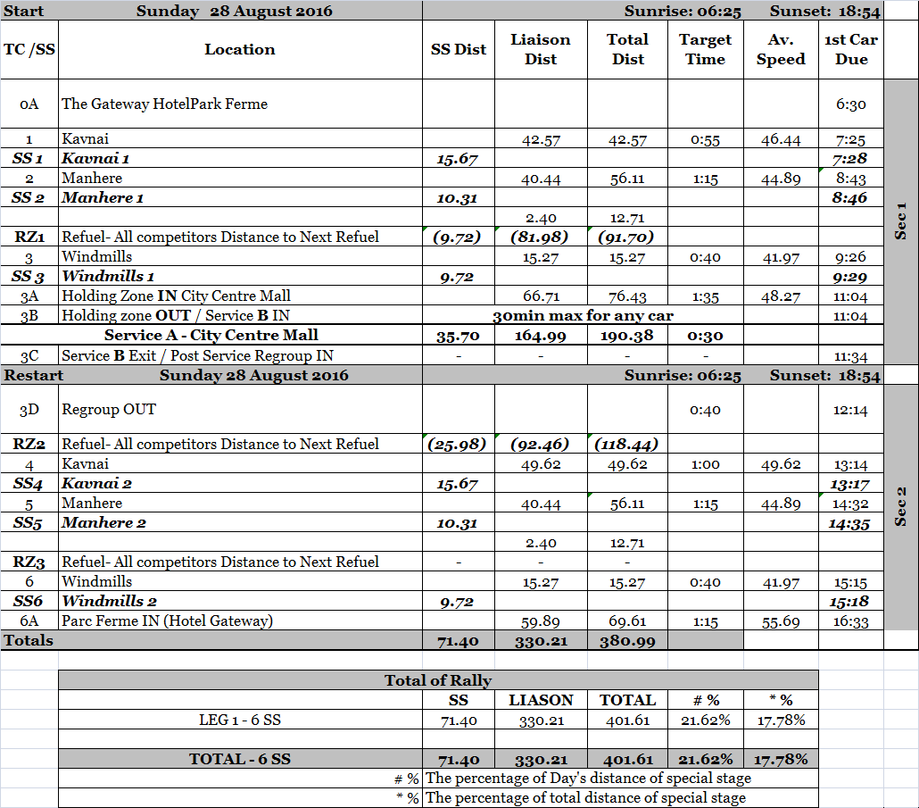
APPENDIX 2 SCHEDULE OF RECONNAISSANCE
Considering the early morning Traffic and road condition it is recommended that you consider 50 minutes time to reach the start of SS1 from Rally H. Q. (dist to travel 42.85 Km)

SS No | SS Distance In Km | Saturday, August 27, 2016 | Time of
 |  |  | Opens | Closes
¼ | 16.15 | 1st Pass | 06:00 | 06.30
 |  | 2nd Pass | 09:15 | 09.45
2/5 | 10.74 | 1st Pass | 07:15 | 07:45
 |  | 2nd Pass | 10:30 | 11.00
3/6 | 10.22 | 1st Pass | 07:55 | 8:25
 |  | 2nd Pass | 11:10 | 11.40

APPENDIX 3 Competitor’s Relation Officer(s)
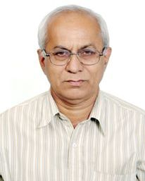

Shrirang Machhe
+91-9373907558
Shrirang.machhe@gmail.com

Will be Present at
Friday, August 26 13.30 – 15.30 During collecting of material & documents
15.30 – 16.00 At Pre-Event Press Conference.
16.30 – End of Curtain Raiser Ceremony.
Saturday, August 27 08.00 – 09.30 At Village Taked after 1st pass of SS 3/6
13.00 - 13.30 At Drivers Briefing meeting.
14:00 At Ceremonial Start
14.45 – 18.00 At Shakedown at Sandip Foundation.
Sunday, August 28 06.30 to 08.00 Start at The Gateway Hotel.
11.00 to 14.15 Service Park at City Centre Mall
17.15 – 18.00 Podium Finish at The Gateway Hotel.
18.00 – 22.00 Rally Secretariat.

APPENDIX 4 .1 COMPULSORY ADVERTISEMENT
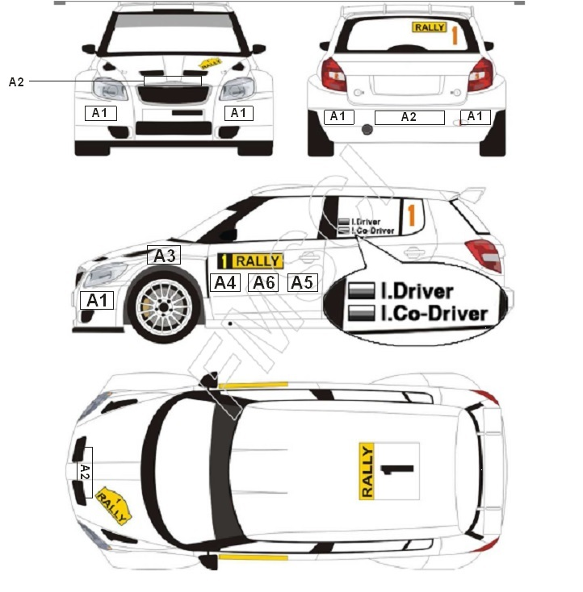
B1 Front door Panel 67 cm X 17 cm
B2 Roof Panel 50 cm X 52 cm
B3 Bonnet Panel 43 cm X 21.5 cm
B4 Rear Window Panel 30 cm X 10 cm
B5 15 cm X 14 cm
B6 Side Window Panel 25 cm (stroke width 25 mm)

APPENDIX 4 .2 OPTIONAL ADVERTISEMENT
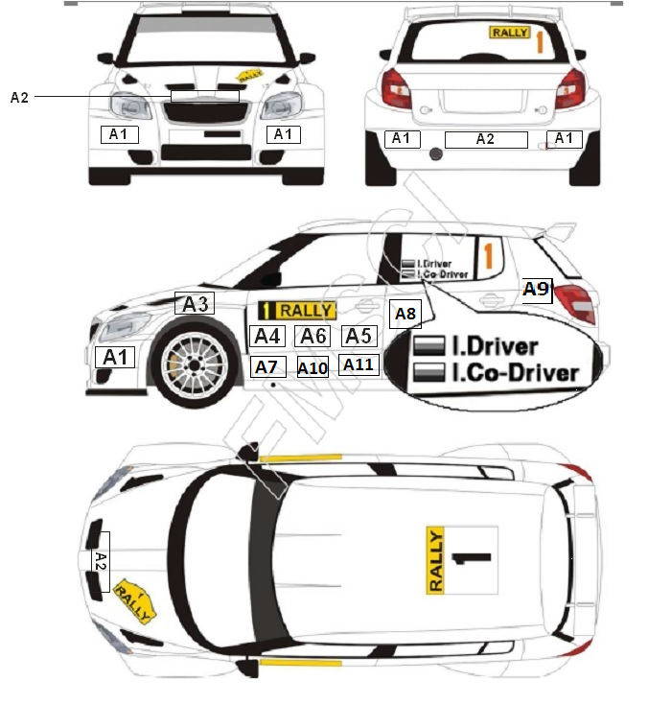
A1 MRF
A2 Mahindra Adventure
A3 York
A4 Mahindra Adventure
A5 Pincon
A6 The Gateway Hotel
A7 Polaris Rear doors
A8 RRPM Rear doors
A9 Red Fm
A10 City Centre Mall
A11 Sandip University

APPENDIX 5 SERVICE PARK PROCEDURES (City Centre Mall)
- The Service Park is located in shopping mall at first floor parking.
- The surface will be concrete.
- The bay size will be (W) 2.5 m X (L) 6.5 m X (H) 2.4 m
- The heavy vehicle or LCV will not be permitted in Service Park.
- The transport of spares required can be done with small pickup vehicles from GFL to First floor Service Park.
- The food court will be located at 3rd floor, you can buy your food from there.
- In the non working hours of the Service Park the spares must be taken out and organisers or mall management will hold no responsibility of it.
- It is recommended that you carry flexible lighting to work on vehicles.
- No trailers can be parked near Service Park
- All bays must be cleaned and use of trampoline or plastic paper bellow car is mandatory.
- Crews will have to ensure that the bays are cleaned before they leave mall on every day. Cleaning agency will be provided by organisers.
- Refuel zone will be of single bay and very limited fuel can be stocked at a Service Park.

