FMSCI HOMOLOGATION FORM

Homologation valid as from

1. GENERAL

101. | Manufacturer

102. | Model and type
 | a) Model and type
 | b) Typical chassis number* |  | * For information purposes only

103. | Cylinder capacity
 | Cylinder capacity |  |  |  | cm3
 | Corrected cylinder capacity |  | X |  | = |  | cm3

104. | Type of car construction
 | a) Type | Separated |  | Unitary construction
 | b) Material of chassis / bodyshell

105. | Number of volumes |  | 106. | Number of places

A1) Car seen from 3/4 front |  | A2) Car seen from 3/4 rear

2. DIMENSIONS, WEIGHT

201. | Minimum weight |  | N
 |  | Kg

202. | Overall length
 |  | Mm + 1%

203. | Overall width |  | II-A1) Where measured
 |  | Mm + 1%

204. | Width of bodywork
 | a) At front axle centreline |  | mm + 1%
 | b) At rear axle centreline |  | mm + 1%

205. | Min. height hub center / Wheel arch opening |  |  | N
 | a) Front |  | mm |  | 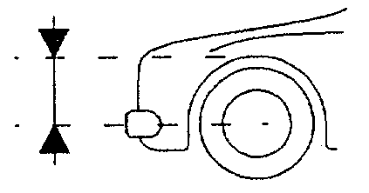
 | b) Rear |  | mm

206. | Wheelbase
 |  |  | mm + 1%

207. | Maximum track (at ground level) |  |  | N
 | a) Front |  | mm
 | b) Rear |  | mm

209. | Overhang
 | a) Front |  | mm + 1%
 | b) Rear |  | mm + 1%

3. ENGINE

301. | Location and position of the engine
 | a) Location and orientation
 | b) Position | X = |  | + 5 mm |  | See scheme III-A1)
 |  | Y = |  | + 5 mm
 |  | Z = |  | + 3 mm
 | c) Inclination |  |  | deg + 30'

C1-1) Dismounted engine – seen from the side |  | C1-2) Dismounted engine – seen from the side

C1-5) Engine in its compartment

III-A1) POSITION OF THE ENGINE

302. | Number of supports | N

303. | Cycle

304. | Supercharging
 | Yes | No | Type and number of compressors

305. | Number and layout of cylinders

306. | Type of cooling

307. | Cylinder capacity
 | a) Unitary |  | cm3
 | b) Total |  | cm3
 | b1) Total corrected |  | X |  |  | = |  | cm3
 | c) Maximum total allowed |  | cm3 |  | NOT VALID IN GROUP N

308. | Total minimum volume of a combustion chamber |  | N
 |  | cm3

310. | Compression ratio (in relation with the unit) |  |  | N
 | Minimum* |  | : 1 | Maximum |  | : 1
 | * Diesel only

311. | Cylinder block
 | a) Material
N | b) Diameter of crankshat bearings |  | +0  - 0.1 mm

C3-1) Bare cylinder block seen from above |  | C3-2) Bare cylinder block seen from underneath

C3-3) Bare cylinder block seen from right hand side |  | C3-4) Bare cylinder block seen from left hand side

C3-5) Bare cylinder block seen from timing side |  | C3-6) Bare cylinder block seen from flywheel side

C3-7) Crankshaft bearing caps

312. | Min. height of the cylinder block |  |  |  | N
 | a) Between sump and head  gasket planes |  | mm | III-C1) Height measurement
 | b)Between crankshaft centreline and head gasket plane |  | mm

313. | Sleeves
 | a) Sleeved cylinder block | Yes | No
N | b) Material |  |  | C3-8) Sleeve dismounted
 | c) Type | Wet | Dry

314. | Bore
+0
- 0.1 mm

315. | Maximum bore allowed
 |  | mm | NOT VALID IN GROUP N

316. | Stroke
+0
- 0.1 mm

317. | Piston |  |  | N
 | a) Material
 | b) Number of rings |  |  | b1) Thickness of rings |  |  |  |  | + 0.1 mm
 | c) Minimum weight |  | g | With pin, clips and rings
 | d) Distance from gudgeon pin center line to top of piston crown |  |  |  | + 0.1 mm
 | e) Distance top of piston at TDC / gasket plane of cylinder block |  |  |  | + 0.15  - 0.30 mm |  | + above  - below
 | f) Piston groove volume (top) |  |  |  | + 0.5 cm3
 | g) Piston colling system |  |  | Yes | No

C4-1) Piston from ¾ top |  | C4-2) Piston from ¾ bottom

III-D1) Piston pin

318. | Connecting rod
 | a) Material |  |  | b) Big end type
 | c) Interior diameter of the big end (without shell bearings) |  |  |  | +0.1  - 0 mm
 | d) Length between axes |  | + 0.1 mm
 | e) Minimum weight |  | g | With cap, bolts and shell bearings

C5-1) Connecting rod from ¾ on big end side |  | C5-2) Connecting rod from ¾ rear on small end side

319. | Crankshaft
 | a) Type of manufacture |  |  | b) Material
 | c) Manufacturing process | Cast |  |  | Forged
 | d) Number of bearings |  |  | e) Type of bearings
 | f) Diameter of bearings |  |  | +0  - 0.1 mm
 | g) Bearing caps material |  |  | h) Min. weight of bare crankshaft |  |  |  | g
N | i) Diamètre maximum des manetons  Maximum diameter of crank pins |  |  | mm

C6-1) Crankshaft from ¾ front |  | C6-2) Crankshaft from ¾ rear

320. | Flywheel
 |  | Manual Gearbox |  | Automatic Gearbox
 | a) Material
 | b) Minimum weight with starter ring |  | g |  | g
 | With fixings and starter ring |  |  | May be used with  automatic gearbox only

C7-1) Flywheel from ¾ front |  | C7-2) Flywheel from ¾ rear

321. | Cylinderhead
 | a) Number
 | b) Material
N | c) Minimum height |  | mm
N | d) Where measured
 | e) Angle between intake valve and cylinder head gasket plane and exhaust valve |  | deg+30´
 | f) Angle between exhaust valve and cylinder head gasket plane and exhaust valve |  | deg+30´
N | g) Minimum volume of a combustion chamber and exhaust valve |  | cm3

C8-1) Bare cylinderhead seen from top (camshaft side) |  | C8-2) Bare cylinderhead seen from underneath (chamber side)

C8-3) Bare cylinderhead seen from intake side |  | C8-4) Bare cylinderhead seen from exhaust side

C8-5) Bare cylinderhead seen from timing side |  | C8-6) Bare cylinderhead seen from flywheel side

C8-7) Combustion chamber

322. | cylinderhead gasket
 | a) Thickness of tightened cylinderhead gasket |  | + 0.2 mm

324. | Fuel feed by injection
 | a) Make and type |  |  |  |  | Direct |  |  |  | Indirect
 | b) Model
 | c) Fuel measurement |  | Mechanical |  |  | Electronic |  |  |  | Hydraulic
 | d) Dimensions of the intake pipe at the throttle valve |  |  |  |  |  | + 0.25 mm
 | e) Number of effective fuel outlets
 | f) Injectors |  | f1) Position |  |  | Manifold |  |  |  | Cylinder head
 | g) List of injection system sensors
 | C1 |  |  | C6 |  |  |  | C11
 | C2 |  |  | C7 |  |  |  | C12
 | C3 |  |  | C8 |  |  |  | c13
 | C4 |  |  | C9 |  |  |  | C14
 | C5 |  |  | C10 |  |  |  | C15
 | h) List of injection system actuators
 | A1 |  |  | A6 |  |  |  | A11
 | A2 |  |  | A7 |  |  |  | A12
 | A3 |  |  | A8 |  |  |  | A13
 | A4 |  |  | A9 |  |  |  | A14
 | A5 |  |  | A10 |  |  |  | A15

C9-1) Injection system complete

III-I1) LOCATION OF SENSORS AND ACTUATORS

325. | Camshaft
 | a) Number |  |  |  |  | b) Location
 | c) Drive system |  |  |  |  | d) Number of bearings per shaft
N | e) Diameter of bearings |  |  | + 0.1 mm
 | f) Type of valve operation system
N | g) Cam dimensions | Intake |  |  | Exhaust |  |  | 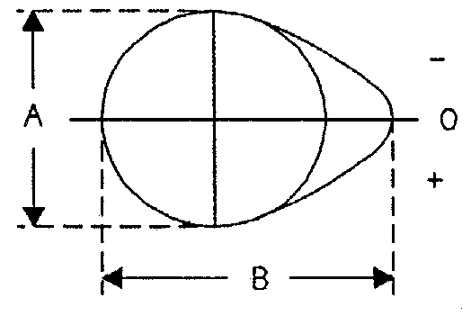
 | A = |  | + 0.1 mm |  |  |  | + 0.1 mm
 | B = |  | + 0.1 mm |  |  |  | + 0.1 mm
 | The tolerances must be used with the same sign for A and B

326. | Timing |  |  |  | N
 | a) Theoretical clearance | Intake |  | mm |  | Exhaust |  | mm
 | b) Cam lift in mm (dismounted camshaft)

INTAKE |  |  |  |  |  | EXHAUST
Rotation  angle in  degrees | Lift in mm  (+ 0.05 mm) |  | Rotation  angle in  degrees | Lift in mm  (+ 0.05 mm) |  | Rotation  angle in  degrees | Lift in mm  (+ 0.05 mm) |  | Rotation  angle in  degrees | Lift in mm  (+ 0.05 mm)
0 |  |  |  |  |  | 0
- 5 |  |  | + 5 |  |  | - 5 |  |  | + 5
- 10 |  |  | + 10 |  |  | -10 |  |  | + 10
- 15 |  |  | + 15 |  |  | - 15 |  |  | + 15
- 30 |  |  | + 30 |  |  | - 30 |  |  | + 30
- 45 |  |  | + 45 |  |  | - 45 |  |  | + 45
- 60 |  |  | + 60 |  |  | - 60 |  |  | + 60
- 75 |  |  | + 75 |  |  | - 75 |  |  | + 75
- 90 |  |  | + 90 |  |  | - 90 |  |  | + 90
- 105 |  |  | + 105 |  |  | - 105 |  |  | + 105
- 120 |  |  | + 120 |  |  | - 120 |  |  | + 120
- 135 |  |  | + 135 |  |  | - 135 |  |  | + 135
- 150 |  |  | + 150 |  |  | - 150 |  |  | + 150
A shift of +/- 2 degrees of the whole measurement is accepted

 | c) Maximum valve lift | Intake |  | Exhaust |  | with clearance according to Art. 326a
 |  |  | + 0.2 mm |  | + 0.2 mm

327. |  | Intake
 |  | a) Material of manifold
 |  | b) Number of manifold elements
 |  | c) Number of valves per cylinder
 |  | d) Maximum diameter of the valve head |  |  |  | mm | d1) Angle of valve head |  |  |  | Deg
 |  | e) Diameter of valve stem in guide |  |  |  | +0  -0.2 mm
 |  | f) Valve length |  |  |  | + 1.5 mm
 |  | g) Type of valve springs
N | h) Number of springs per valve
N | i) Max. length of the spring |  |  |  | mm |  |  | Under a load of |  |  |  | N
N | j) External diameter of springs |  |  |  | + 0.2 mm |  |  | k) Number of spring coils
N | l) Diameter of spring wire |  |  |  | + 0.1 mm |  |  | m) Max. free length of springs |  |  |  | mm

C11-1) Intake manifold - dismounted |  | C11-2) Intake manifold - dismounted

C11-3) Throttle unit - dismounted |  | C11-4) Throttle unit - dismounted

INTAKE
Drawings of engine ports - tolerances on dimensions : -2%, +4%
III-K1) Cylinderhead, manifold side
III-K2) Manifold, cylinderhead side

328. | Exhaust
 | a) Material of manifold |  |  |  | b) Number of manifold elements
 | c) Internal dimensions of manifold exit |  |  | + 0.2 mm | + 2.0 mm if raw or fabricated
 | d) Number of valves per cylinder
 | e) Maximum diameter of the valve |  |  | mm | e1) Angle of valve head |  |  | deg
 | f) Diameter of valve stem in guide |  |  | +0  -0.2 mm | g) Valve length |  |  | + 1.5 mm
 | h) Type of valve springs
N | i) Number of springs per valve
 | j) Max. length of the spring |  | mm |  | Under a load of |  |  |  | N
 | k) External diameter of springs |  | + 0.2 mm |  | l) Number of spring coils
 | m) Diameter of spring wire |  | + 0.1 mm |  | n) Max. free length of springs |  |  |  | mm
 | o) Diameter of pipe between manifold and first silencer |  |  |  |  | mm + 5%

C12-1) Exhaust manifold - dismounted |  | C12-2) Exhaust manifold - dismounted

EXHAUST
Drawings of engine ports - tolerances on dimensions : -2%, +4%
III-L1) Cylinderhead, manifold side
III-L2) Manifold, cylinderhead side

329. | Anti-pollution system |  | N
 | a) Description

C12-3) Complete exhaust system - dismounted

330. | Ignition system
N | a) Type |  |  | d) Number of coils
 | b) Number of plugs per cylinder
 | c) Number of distributors

331. | Cooling system |  |  | N
 | a) Capacity |  | litres

332. | Cooling fan |  | N
 | a) Number |  | b) Max. diameter of the fan |  | mm
 | c) Material of the fan |  | d) Number of blades
 | e) Type of drive |  | f) Automatic cut off | Yes | No

III-M1) Dimensions of radiator cores

333. | Lubrication system
 | a) Type
 | b) Number of oil pumps
N
 | c) Total Capacity |  | litres
 | d) Oil cooler(s) | Yes | No | d1) Number
 | e) Location of the coolers |  |  | f) Type of the coolers
DELETE THIS PAGE AND THIS HEADING IF ENGINE IS NOT SUPERCHARGED

334. | Turbocharging
 | a) Make and type of the turbocharger
 | b) Turbine housing | b1) Number of exhaust gas entries
 |  | b2) Material
 | c) Roue de turbine  Turbine wheel | c1) Material
 |  | c2) Number of blades
 |  | c3) Height(s) of blades |  | + 0.5 mm
 |  | c4) Dimensions A, B, C, according to the sketch | 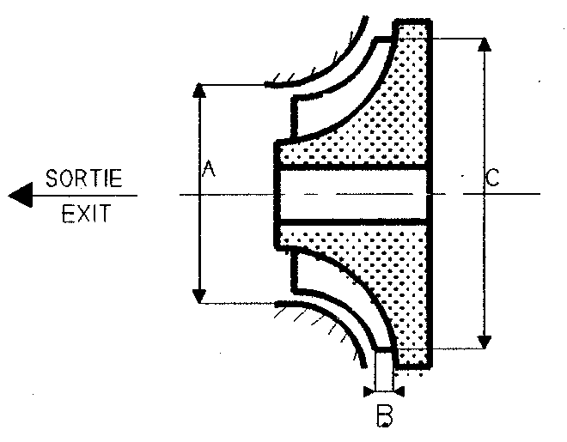
A = + 0.4 mm
B = + 0.5 mm
C = + 0.3 mm
 |  | c5) Variable blades | Yes | No
 | d) Impeller housing | d1) Number of air entries (mixture)
 |  | d2) Material
 | e) Impeller wheel | e1) Material
 |  | e2) Number of blades
 |  | e3) Height(s) of blades |  | + 0.5 mm
 |  | e4) Dimensions A, B, C, according to the sketch
A = + 0.4 mm
B = + 0.5 mm
C = + 0.4mm
 |  | e5) Variable blades | Yes | No
DELETE THIS PAGE AND THIS HEADING IF ENGINE IS NOT SUPERCHARGED

 | f) Pressure regulation | f1) Type of pressure adjustment |  |  | By-pass |  | Relief valve |  |  |  | Other
 |  | f2) Type of pressure adjustment
 | g) Exhaust system | g1) Internal dimensions of the possible pipes between manifold and turbocharger
 |  |  |  |  | + 2mm
 | h) Cooling of intake air | h1) | Yes |  |  |  |  | No
 |  | h2) System | Air | Air/Water |  |  |  | Single-flow |  | Double-flow
 |  | h3) Air inlet diameter |  |  |  |  |  |  | + 1mm
 |  | h4) Air outlet diameter |  |  |  |  |  |  | + 1mm
 | i) Maximum absolute supercharging pressure |  |  |  |  | mbar

III-01) Exhaust gas inlet to the turbine housing |  | III-02) Exhaust gas outlet from the turbine housing

III-03) Air (gas) inlet to the compressor housing |  | III-04) Air (gas) outlet from the compressor housing
DELETE THIS PAGE AND THIS HEADING IF ENGINE IS NOT SUPERCHARGED

C15-1) Plan view of complete turbocharger unit |  | C15-2) Front view of complete turbocharger unit

C15-3) Side view of complete turbocharger unit |  | C15-4) Valve and by-pass installation of turbocharger

C15-5) Exhaust system between manifold and turbocharger
DELETE THIS PAGE AND THIS HEADING IF ENGINE IS NOT SUPERCHARGED

C15-6) Compression housing of turbocharger - dismounted |  | C15-7) Turbine housing of turbocharger - dismounted

C15-8) Intercooler - dismounted |  | C15-9) Intercooler - mounted in its location

III-05) Drawing of the intercooler with dimensions of core (Width x Height x Thickness)
DELETE THIS PAGE AND THIS HEADING IF ENGINE IS NOT SUPERCHARGED

III-06) DEVICE REGULATING THE TURBOCHARGER PRESSURE
Procedure for checking the pressure

III-07) INTERCOOLER COOLING SYSTEM

4. FUEL CIRCUIT

401. | Fuel tank
 | a) Number
 | b) Location
 | c) Material
N
 | d) Total capacity |  | litres
 | e) Location of filler holes

402. | Fuel pump(s) |  |  | N
 | a) Type
 | b) Number
 | c) Make and type
 | d) Location
 | e) Maximum flow |  | l / mn |  | at |  | volts

5. ELECTRICAL EQUIPMENT

501. | Batteries
 | a) Number
 | b) Tension |  | Volts
N
 | c) Location

502. | Alternator |  | N
 | a) Type
 | b) Number
 | c) Drive system
 | d) Nominal power |  | Watts

503. | Retractable headlights |  | N
 | a) Control system

6. POWER TRAIN

601. | Driven wheels
 |  | FRONT | REAR

VI-A1) KINEMATIC TRAIN (4-wheel drive only)

602. | Clutch |  |  | N
 | a) Type |  |  | b1) Operation | Pushed | Pulled
 |  |  |  | d) Diameter of the plate(s) |  | + 2 mm
 | b) Control system
 | c) Number of plates

F1-1) Clutch bell housing

F1-2) Pressure unit dismounted with disc(s) |  | F1-3) Pressure unit dismounted with disc(s)

603. | Gearbox
 | a) Location
 | b) Make Manual |  |  |  |  |  |  |  | c) Make Automatic
 | d) Type and location of control
 | e) Gear ratios
 |  | Manual |  |  |  |  |  |  |  |  | Automatic
 |  | Number of teeth | Ratio | Constant | Synchro |  |  |  |  |  | Number of teeth |  |  | Ratio | Synchro
 | 1 |  |  |  |  |  |  |  |  | 1
 | 2 |  |  |  |  |  |  |  |  | 2
 | 3 |  |  |  |  |  |  |  |  | 3
 | 4 |  |  |  |  |  |  |  |  | 4
 | 5 |  |  |  |  |  |  |  |  | 5
 | 6 |  |  |  |  |  |  |  |  | 6
 | AR/R |  |  |  |  |  |  |  |  | 7
 | Constant |  |  |  |  |  |  |  |  | AR/R
 | f) Gear change gate
 | g) Type of lubrication
N
 | h) Oil cooler(s) |  |  | Yes |  | No |  | h1) Type

F2-1) Gearbox casing and clutch bell housing |  | F2-2) Gearbox casing and clutch bell housing

604. | Transfer box
 |  | High |  | Low
 | b) Ratios
 | b1) Number of teeth
 | c) Control system
 | d) Type of central differential
N
 | e) Torque distribution | FRONT |  |  | REAR
 |  |  | % |  |  |  | %
 | e1) Number of teeth
 | f) Type of central differential limitation

605. | Final drive
 |  | FRONT |  | REAR
 | a) Type of final drive
 | b) Ratio
 | c) Number of teeth
 | e) Type of lubrication
N
 | d) Type of differential limitation
 | d1) Make
 | f) Oil cooler | Yes | No | Yes | No
 | f1) Type

F4-1) Front differential casing |  | F4-2) Front differential casing

F4-3) Front differential assembly |  | F4-4) Front differential dismounted

VI-D1) Drawing of front differential rails with angles

F5-1) Rear differential casing |  | F5-2) Rear differential casing

F5-3) Rear differential assembly |  | F5-4) Rear differential dismounted

VI-E1) Drawing of rear differential rails with angles

606. | Transmission shafts
 |  | FRONT | REAR
 | a) Type of longitudinal shafts and joints
 | b) Material of longitudinal shafts
 | c) Type of transversal half shafts and joints
 | d) Material of transversal half shafts

7. AXLES AND SUSPENSION

701. | General
 |  | FRONT | REAR
 | a) Type of axle

702. | Helical springs
N
 |  |  | FRONT |  | REAR
 | a) Material

703. | Learf springs
N
 |  |  | FRONT |  | REAR
 | a) Material of main leaves
 | a1) Material of auxiliary leaf

704. | Torsion bars
N
 |  |  | FRONT |  | REAR
 | a) Material

G1-1) Complete front axle assembly - dismounted |  | G1-2) Complete front axle assembly - dismounted

H1-1) Complete rear axle assembly - dismounted |  | H1-2) Complete rear axle assembly - dismounted

G2-1) Subframe for fixing the front axle parts - dismounted |  |  | G2-2) Subframe for fixing the front axle parts - dismounted

H2-1) Subframe for fixing the rear axle parts - dismounted |  |  | H2-2) Subframe for fixing the rear axle parts - dismounted

705. | Other type of suspension
 |  | FRONT | REAR
 | a) Type
 | b) Number of elastic elements
 | c) Type of elastic elements

706. | Stabilisers
 |  | FRONT |  | REAR
 | a) Material
 | b) Effective length between bearings |  | mm +1% |  | mm +1%
 | c) Effective diameter (ext. x int.) |  | mm |  | mm

VII-F1) Front stabiliser with dimensions |  | VIII-F1) Rear stabiliser with dimensions

707. | Shock absorbers
 |  | FRONT | REAR
 | a) Number per wheel
 | b) Type
 | c) Principle of operation

8. RUNNING GEAR

801. | Wheels
 |  |  | FRONT |  |  |  | REAR
 | a) Diameter |  |  |  | mm |  |  |  | mm
 |  |  |  |  | inches |  |  |  | inches
N
 |  | FRONT |  |  |  | REAR
 | b) Width |  |  | mm |  |  |  | mm
 |  |  |  | inches |  |  |  | inches

802. | Spare wheel
 | Location |  | J2-1) Spare wheel in its location

803. | Brakes
 | a) Braking system
 | b) Number of master cylinders |  |  |  | b1) Bores |  | / |  |  | + 0.05 mm
 | c) Servo brakes | Yes | No |  | c1) Make and type
 | d) Braking regulator | Yes | No |  | d1) Location
 |  |  |  |  | d2) Type
 |  |  |  | FRONT |  |  |  | REAR
 | e) Number of cylinders per wheel
 | e1) Bore |  |  |  |  | + 0.1 mm |  |  | + 0.1 mm
 | f) Drum brakes
 | f1) Internal diameter |  |  |  |  | +1.5 mm |  |  | +1.5 mm
 | f2) Number of linings per wheel
 | f3) Developed length of each lining |  |  |  |  | +1.5 mm |  |  | +1.5 mm
 | f4) Width of each lining |  |  |  |  | + 1 mm |  |  | + 1 mm

 | g) Disc brakes
 | g1) Number of pads per wheel
 | g2) Number of calipers per wheel
 | g3) Caliper material
 | g4) Thickness of new disc |  | +1 mm |  | +1 mm
 | g5) External diameter of disc |  | +1.5 mm |  | +1.5 mm
 | g6) External diameter of pads'rubbing surface |  | +1.5 mm |  | +1.5 mm
 | g7) Internal diameter of pads'rubbing surface |  | +1.5 mm |  | +1.5 mm
 | g8) Overall friction length of each pad |  | +1.5 mm |  | +1.5 mm
 | g9) Ventilated discs | Yes | No | Yes | No
 | Number of venting channels

 | h) Parking brake
 | h1) Control system
 | h2) Location of control
 | h3) On which wheels | FRONT | REAR
 | h4) Location of brake

FRONT |  | REAR

J3-1) Complete brake assembly |  | K3-1) Complete brake assembly

804. | Steering
 | a) Type
 | b) Ratio |  |  |  | Steering wheel / Wheels
 | c) Power assisted | Yes | No
 | d) Type of power assistance
 | e) Location of power assistance
 | f) Location of electronic control unit

J9-3) Steering rod - dismounted |  | X-C1) Steering rod – typical dimensions
Ref :

9. BODYWORK - CHASSIS (BODYSHELL)

901. |  | Interior
 |  | a) Heating | Yes | No
N | b) Climatisation  Air conditioning |  | Yes | No
 |  | c) Optional sun roof | Yes | No | c1) Type
 |  |  |  |  | c2) Control System
 |  | d) Opening system for side windows
 |  | Interior dimensions as defined by the Homologation Regulations

 |  |  |  |  | XII-A1)
 | B | Height above front seats |  | mm | 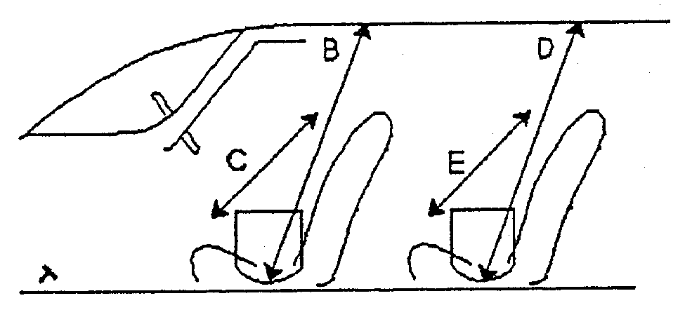
 | C | Width at front seats |  | mm
 | D | Height above rear seats |  | mm
 | E | Width at rear seats |  | mm
 | F | Steering wheel - Brake pedal |  | mm | 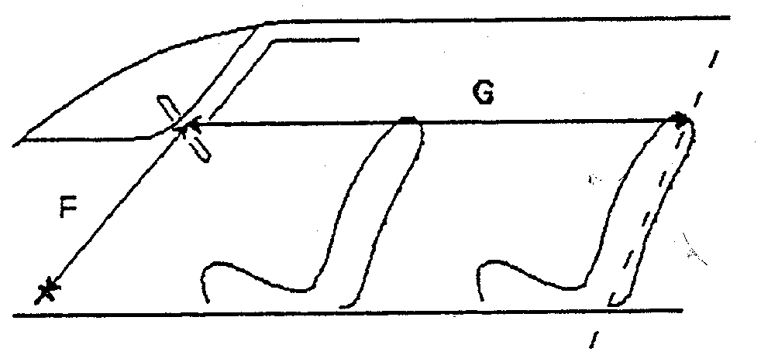
 | G | Steering wheel - Rear bulkhead |  | mm
 | H | F + G |  | mm

L1-1) Dashboard

902. | Exterior
 | a) Number of doors |  |  | b) Tailgate | Yes | No
N
 | d) Rear wiper
 | c) Windscreen |  | c1) Heating / defrosting system |  | Yes | No
 |  |  | c3) Minimum weight |  |  | kg

XIII-A1) MATERIALS OF BODYWORK PANELS

METALLIC MATERIALS
Label | Part | Material
01
02
03
04
05
06

PLASTIC MATERIALS
Label | Part | Material
11
12
13
14
15
16

GLAZING
Label | Part | Material | Min. thickness
21 |  |  |  | mm
22 |  |  |  | mm
23 |  |  |  | mm
24 |  |  |  | mm
25 |  |  |  | mm
26 |  |  |  | mm

DRAWING

M1-1) Sunroof

903. | Chassis (Bodyshell)

N1-1) Bare chassis – General view |  | N1-2) Bare chassis – General view

N1-3) Bare chassis – Engine compartment |  | N1-4) Bare chassis – Cockpit seen from windscreen opening

N1-5) Bare chassis – Cockpit seen from rear window opening |  | N1-6) Bare chassis – Roof seen from cockpit

N1-7) Bare chassis – Luggage compartment |  | N1-8) Bare chassis – Seen from underneath

COMPLEMENTARY INFORMATION

